Kent County High School
2022 Summer Reading Assignment
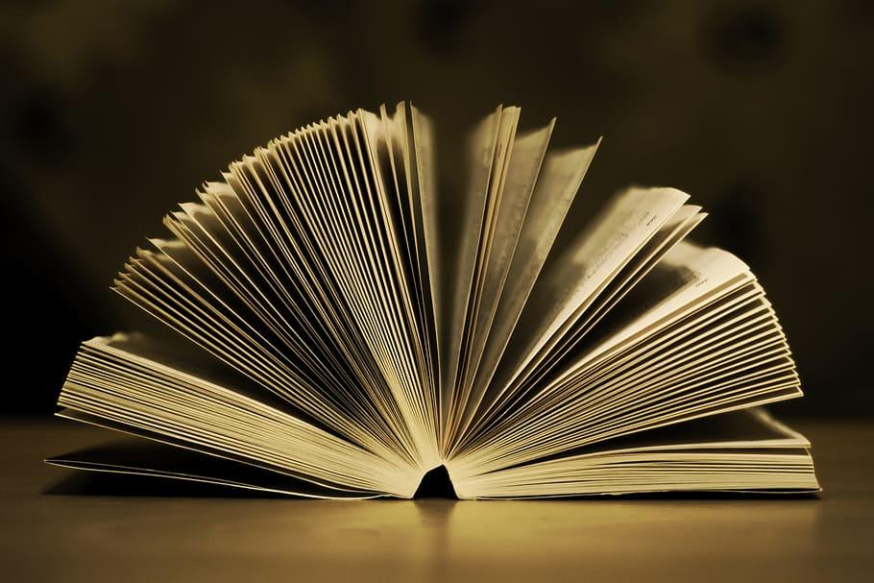

Directions:
This year, we would like you to read at least one book of YOUR choice. If you aren’t sure which books you would like, do some research! Get suggestions from your peers, parents or guardians, or look up authors you’ve loved in the past for some ideas. The only requirement is that you cannot choose books you’ve already read, or that are in the curriculum from KCPS (again, they cannot be books you’ve already read).

What gets turned in?
After you’ve chosen a book, and LOVED reading it, you will have one assignment to complete. Attached you will find a Choice Board. You must complete one choice from the board below before school in September.

Help the Kent County Public Library reach the summer reading goal of 750,000 minutes read by the community.

8 hours, 4 books, or 15 minutes a day 5 days a week, however you want to track it, just keep reading!

See below for more information about the summer reading program for everyone at the Kent County Public Library.

Creative Choices
After reading at least one book of your choice, choose & complete one of the options below from the choice board.

Ever finish a book and wish it ended differently? Now is your chance to change the ending! Write a new last chapter to the book. When writing, remember to mimic the author’s style so the chapter feels consistent with the rest of the book. | Create a song playlist that relates to the book. Be sure to put the songs in order of the storyline (exposition, inciting incident, rising action, crisis, climax, falling action, resolution) and write a brief explanation as to why you chose that song for that particular moment in the book. | Create a game (game board with questions/items that directly relate to characters, events, themes of the novel OR a digital game that relates to the events, themes or characters in the novel).
Create a piece of art that demonstrates one theme of the novel. The artwork can be in any medium (pencil sketch, watercolor, acrylic, collage, paper mache, digital) and must include the book title, author, and a brief theme statement. | Write an original poem or original song that relates to a theme of the novel. Consider the genre you wish to use as well as rhyme scheme and rhythmic details. | The missing chapter - brainstorm, and craft a chapter that you believe should be included in the book. This could be a prologue or epilogue, or a chapter anywhere else in the novel. This does not need to match the length of the actual chapters unless you want to!
Write a book review. Come up with a rating system and assess the book based on how you would score it. Make sure you have detailed explanations about why you’ve scored it this way. | Comic book-ify your novel. You may draw by hand or use an online site of your choice. Make sure to get at least 9 frames in. | Write a letter to the author asking questions about the decisions made regarding plot, characterization, setting, and time period. Make two copies - one to turn in and one to send to the author.

